Ticket availability and discounts About Us

Individual tickets for all of our concerts cost £18.

The Club is aided by the Cavatina Trust and is pleased to offer free admission to young people aged 8 to 25 years of age. Children must be accompanied by an adult.

Tickets can be purchased at the door with cash or credit cards for all concerts.

Advance tickets for our October 2023, November 2023, February 2024 and March 2024 concerts can be purchased from The Radlett Centre, details below.

Advanced tickets for the January 2024 and April 2024 concerts can be purchased from our website www.radlett-music-club.co.uk later in the year.

Membership of the club will give you access to all 6 concerts for £75. For further details see the back page of this leaflet.

Venues

The Radlett Centre is at 1 Aldenham Avenue, WD7 8HL in the centre of Radlett with free parking nearby. Box Office: 01923 859291
www.radlettcentre.co.uk

Radlett Reform Synagogue for the January 2024 concert is at 118 Watling St, Radlett, WD7 7AA with free parking nearby.

Edge Grove School for the April 2024 concert is accessed from High Cross, off Radlett Road (B462), Aldenham, WD25 8NL with free parking at the school.

The Radlett Music Club has been presenting fine, live music since 1936. We aim to put on a varied programme to appeal to a wide variety of interests. We engage experienced artistes who have already established careers, and talented young performers many of whom go on to achieve considerable success.

Further information about the artistes and the details of the concerts are on our website.

Unless otherwise noted all of our concerts are held at the Radlett Centre with its extensive facilities, tiered seating, foyer café and bar. Seats are unreserved.

Membership of the Club allows entry to all concerts at a saving of more than 30% over the individual door price of £18. It also includes a free programme at each concert. Membership is transferable - if you can’t come to any concert a friend can come in your place. A membership application form is available on our website or please contact us at membership@radlett-music-club.co.uk.

Radlett Music Club is a Registered Charity No.278246.
Patron: John Apthorp CBE

Radlett Music Club website
www.radlett-music-club.co.uk

Fine live
classical concerts

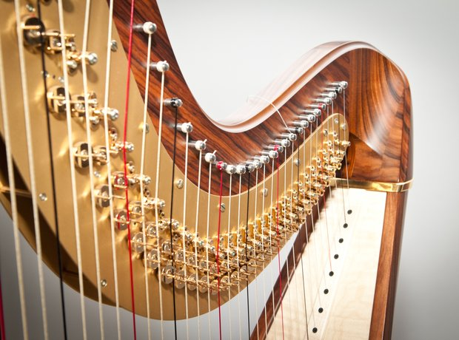

London quality music on your doorstep

2023-2024 Season

Carducci String Quartet
Margaret Fingerhut (piano)
Frederico Paixão (flute), Milo Harper (harp)
Ignas Maknickas (piano)
Wihan Quartet from Prague
Purcell School

www.radlett-music-club.co.uk
Carducci String Quartet
Concert Dates and Artistes

Tuesday 17 October 2023 at 7:30 pm

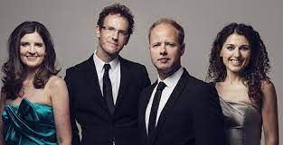

Mozart String Quartet in B flat major K458 (the Hunt}
Dvorak String Quartet No 12 in F major, Op 96
(The American)
Beethoven String Quartet in E minor Op 59, No 21

Margaret Fingerhut (piano)
Wednesday 8 November 2023 at 7:30 pm
“Around the world in 88 piano keys”

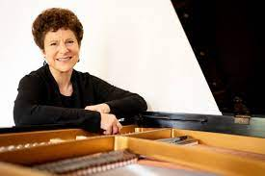

Playing music by
Grieg, Liszt, Bartok, Albeniz and others

Frederico Paixão (flute)
The right is reserved to substitute artistes and vary advertised programmes without notice if necessary.
Milo Harper (harp)
Sunday 28 January 2024 at 3 pm

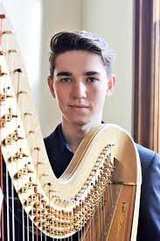
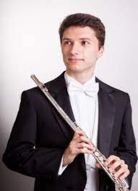
3PM At RADLETT REFORM SYNAGOGUE

Music to include:
Coleridge-Taylor Deep River
Price Adoration
Tournier Danse du Moujik
Gluck Dance of the Blessed Spirits
Faure Sicilienne from Pelleas et Melisande

Ignas Maknickas (piano)
Wednesday 28 February 2024 at 7:30 pm

Schumann Kinderszenen Op. 15
Alvydas Remesa Five Miniatures for Piano
Chopin Polonaise-Fantasie Op. 61
Schubert Sonata in B-flat, D. 960

(please note change of programme)

Wihan Quartet from Prague Wednesday 13 March 2024 at 7:30 pm

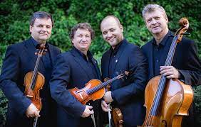

Janacek String Quartet No 1 (Kreutzer Sonata)
Dvorak String Quartet No 10 in E flat major, Op 51
Smetana String Quartet No 1 in E minor 'From my Life'…

Students from the
Purcell School
Sunday 28 April 2024 at 3 pm
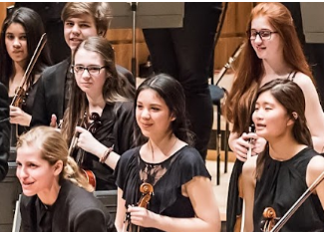

3PM At EDGE GROVE SCHOOL

The Purcell School is the oldest specialist music school in the UK with Sir Simon Rattle as its honorary president. Famous alumni include Martin Bartlett, Oliver Knussen and Yevgeny Sudbin.
Please check our website nearer the time for further concert details

